C O C K T A I L B A R BRUNCH AT HICKIES R E S T A U R A N T

BRUNCH IS SERVED FROM 10.00AM TO 1PM DAILY

FULL IRISH .............................................................. €12.50
Jack Kelly’s sausages, North Kerry rashers, black & white pudding, fried egg, mushrooms, grilled tomato
1,2,5,9,13,14,

MINI BREAKFAST ................................................ €8.00
Jack Kelly sausage, North Kerry rasher, black & white
pudding, mushrooms, fried egg
1,2,5,9,13,14,5

GLUTEN FREE FULL IRISH ................................ €14.00
Jack Kelly’s sausages, North Kerry rashers, black & white pudding, fried egg, mushrooms, grilled tomato, gluten free bread
1,2,5,9,13,14,15

POACHED EGGS ..................................................... €9.50
Served on homemade brown bread, avocado, rocket 1,2,9,13,14,15

SCRAMBLED EGGS ............................................... €12.00

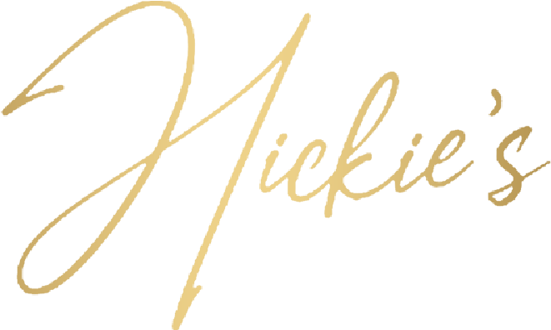
On toast, served with smoked salmon €14.00 cheese & bacon €12.00 1,2,3,5,9,13,14,15

HOMEMADE SCONE ............................................. €4.00
Served with butter & jam
1,2,9,13,15

TEAS & COFFEE

Americano ..................................... €3.50
Cappuccino .................................... €4.00
Latte ................................................. €4.00
Espresso ......................................... €3.00
Iced Latte ........................................ €4.00
Barry’s Irish Tea .......................... €3.00
Hot Chocolate ............................... €3.50
CREPES Choice of:
Nutella, syrup & strawberries .................................. €10.00 Smoked salmon, cream cheese & dill ................. €14.00
1,2,3,6,9,13,14,15

FRENCH TOAST .................................................... €14.00
Smoked streaky bacon, maple syrup on brioche bread, berry compote
1,2,9,13,14,15

PORRIDGE ................................................................ €6.00
Served with a choice of toppings: granola, berry
compote, mixed seeds
2,6,9,12,13,14,15

FRESH FRUIT SALAD .......................................... €6.00
Natural yogurt, honey drizzle

BREAKFAST BAP .................................................. €10.00
Bacon, egg, sausage, pudding, relish
1,2,5,9,13,14,15

SIDES
French Fries ............................................................ €4.50
Brown Bread & Butter .......................................... €3.50

Toast .......................................................................... €2.50

BRUNCH COCKTAILS
SERVED FROM 12PM

Mimosa ............................................................. €9.00
Prosecco Frizzante & Fresh Orange juice
Bloody Mary .................................................... €9.50
Istil Vodka, Tomato Juice, Celery, Salt, Worchester Sauce
Orange Spritz .................................................. €10.00

All our dishes are Prepared & Cooked to order. Please allow 20 minutes . Thank you.
Allergens Available on Request

